The Drive Screening Test

The new Drive Screening test is a multi-bus, multi-drive test designed for quickly testing large numbers of disk drives.

What the test does

The Drive Screening test will scan all SCSI and FibreChannel busses in your system, and will identify all disk drives that are connected. Once all disks are discovered the INQUIRY data, drive serial number, capacity, and number of defects is displayed.

When the test is started, the SCSI VERIFY command is sent to all blocks on all drives. The test will fail on two conditions:

- If the VERIFY command fails, the test fails that drive. All other drives remain testing.
- If the number of grown defects increases to a value of 1 or more, the test fails that drive. All other drives remain testing.

The test will continue until the percentage specified in the Percentage of Drive to Test field has been tested.

At the conclusion of the test, the results may be saved to a file by clicking the Results->File button.

An Example

Here is a screen shot of our test system, showing a Fibre Channel HBA with eight disk drives, and a SCSI HBA with three disks.

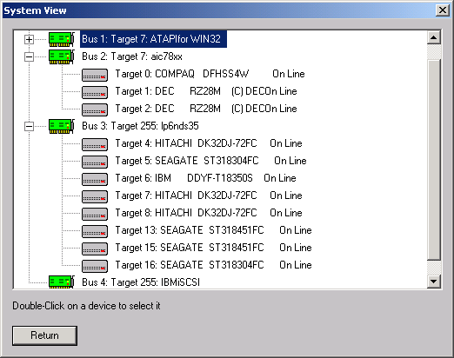

Selecting the Drive Screening Test from the Disk->Test menu shows this screen

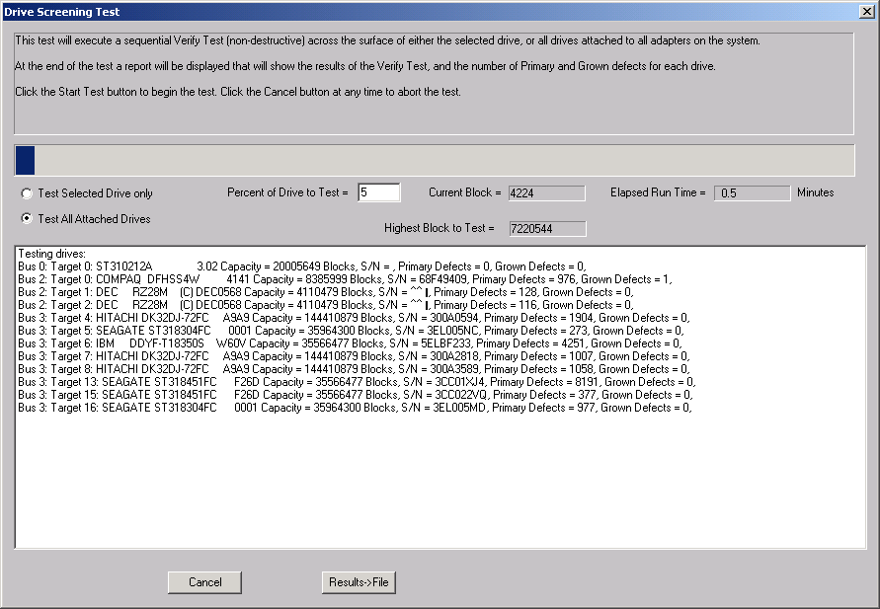

A few things to notice –

- You can choose to test either all attached drives, or only the selected drive
- You can specify what percentage of the drives to test
- The first drive displayed in our example is the system ATA boot drive due to our ATAPI support in version 3.9
- Some of the older drives do not report a serial number
- The second drive in our example has a grown defect – this drive will be rejected

As the test runs you will see the current lba being tested, and the elapsed run time.

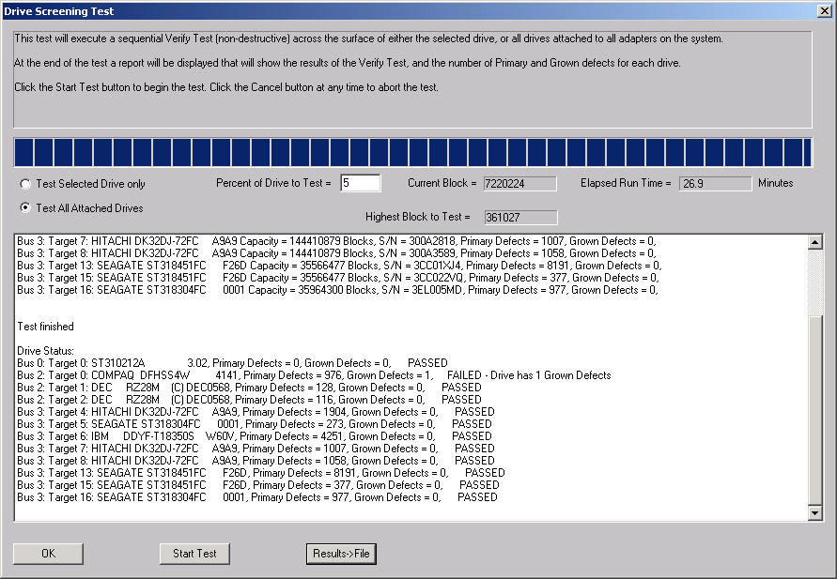

Here is the display of the test once it has finished.

Note that the second drive was failed, and that the test notes that it failed due to having Grown Defects.

Clicking on the Results->File button will save a time-stamped copy of this information to a user-specified file.

What is in the future for the Drive Screening Test

The next major release of the SCSItoolbox will have the following additions to the Drive Screening Test:

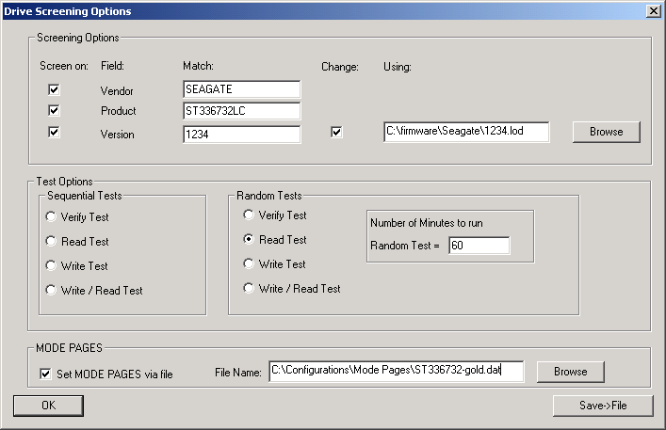

These screening options allow drives to be rejected if any or all of their INQUIRY VENDOR, PRODUCT, or VERSION data does not matched the values specified.

The Change and Using choices allow the firmware of the drive to be changed if it does not match the specified version, by downloading the firmware file specified in the Using: field.

Various Sequential and Random tests are selectable.

All of the MODE PAGES are able to be set from a file. This allows a “gold” drives MODE PAGES to be recorded, and when the Drive Screening test is run all drives will have their MODE PAGES set to conform to the “gold” drive settings.

