

SCSI Command Compliance Testing

SCSI command compliance testing insures that the peripheral under test can properly interpret and execute any legal SCSI CDB that it receives, and that it also reports the proper error information when it receives an illegal SCSI CDB.

If you need to test a device for SCSI compliance, you don’t need to feel that the weight of the world is on your shoulders. You don’t need a book full of maps to find a SCSI command compliance test, because this test is provided to all SCSItoolbox customers, for free! It is one of the many ScriptwriterPro examples included with the SCSItoolbox!

In your SCSItoolbox folder, there is a folder called Complience Test. (Yes, we know that it should be spelled “Compliance”, and you can certainly change the name of the folder if things like that bother you.) In this folder is a SWP script called “Compliance Test.bas” (see, we got the spelling right on that one!). This test is all you need to check command compliance of any type of SCSI device.

Here’s how you run the test:

Start up the ScriptwriterPro editor, and using the File->Open menu choice navigate to the program files\STB\SCSI Toolbox32\Complience Test folder (we’ll never live down this spelling mistake!). Open the file “ComplianceTest.bas”. You’ll see the source code for a wonderful SWP example program that has a GUI and everything! For now, just press your F5 key to start the program.

Here’s what you’ll see:

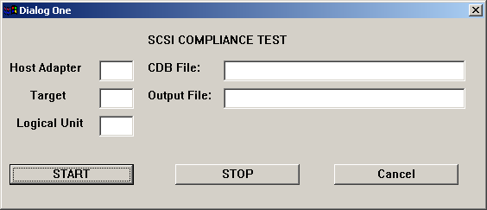

Now, fill in the Host Adapter, Target, and Logical Unit fields with the address of the device you want to test. Also, fill in the CDB File with the test CDB input file you want to use. In this case we are going to test a disk for compliance with legal disk commands, so we will specify the file “DiskTest.dat”. If we were testing illegal commands we would use the file “Illegal Disktest.dat”.

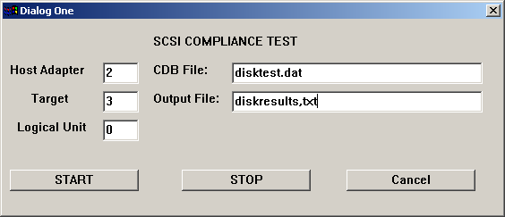

We have specified the device to test, which CDB’s to test it with, and we have specified the name of our output file. Now, Click the START button.

When the test is finished you will see

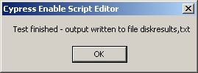

Opening our output file shows us each command that was sent to the device, and whether the CDB was executed without error or not. If an error occurred, the Sense data is displayed.

For example, here is an excerpt from the output file:

CDB[READ BUFFER]= 3C,00,00,00,00,00,00,00,FF,00 passed

CDB[SEND DIAGNOSTIC]= 1D,00,00,00,00,00 failed Sense = 05/24/00

Complete documentation on command compliance testing issues, how to run the test, and how to modify or add to the CDB files is also included, and can be found in the same folder – that’s right, the folder where we spelled Compliance wrong!

